**Introduction to Evolutionary Biology**

20.9.17

**Darwinian evolution**: Descent with modification: It is classified by microevolution (species change over time), macroevolution (new life forms derive from older ones), speciation (lineages split and diverge) and common ancestry (all life forms are related).

**Direct observation of evolution**: microevolution (short term changes)  
**Ex.**: Bacterial adaption to antibiotic stress.

**Indirect observation of evolution**: macroevolution (long term changes)

**Def. LUCA**: Last common universal ancestor

27.9.2017

**On Natural Selection**

If artificial selection works rapidly during domestication, the same process must happen in nature **at different speeds though**.

**4 postulates for evolutionary growth**:

1. All population contain variable individuals
2. Variations among individuals are at least in part heritable
3. Some individuals are more successful at surviving and reproducing than others
4. Survival and reproduction of induvials are not random but individuals with the most favourable variables in their environment are the most successful.

**Heratibility**: phenotype = genotype/(genotype+environment), in %.

Factors biasing heritability measures: misidentified paternity (father is unfaithful), misidentified maternity (mother gives her egg to another nest), food quality (bigger offspring, independent of parents), maternal effects (egg quality, depending on hormones and nutrients in the egg).

The food quality can give an overestimation of heritability. We need a genetic basis to be sure who the actual parent was.

**Survival and reproduction**: Is influenced by environmental factors: Example of finches of Major Daphne: Drought:

Reduced seeds and different sizes of seeds – there was a huge in decline in population, therefore, there was a huge selection pressure on the individuals.

This lead to a huge decrease in finches with small beaks and big beaks had a better survival chance.

The population evolved, because the average beak sized grew.

**Epigenetic mechanisms** are affected by: development (in utero, childhood), environmental chemicals, drugs and pharmaceuticals, ageing, diet. Epigenetic changes are reversal though.

The offspring and the offspring’s offspring is affected by epigenetic changes. Epigenetics is relevant for short-term evolution.

4.10.2017

**On phylogenetics**

**Def. basal group**: In phylogenetic tree, it is the group that split off from the primary ancestor first (it is merely one branch and does not split off into other branches (**exception**: there can be several organisms in a basal group ⬄ no more than 1 further mutation may occur in a basal group) – normally in a picture, it is at the top or at the bottom, since it has the fewest derivations ⬄ it is more similar to the most recent ancestor than all other taxa).

**Def.** **plesiomorphy**: An ancestral character or trait state shared by two or more taxa. 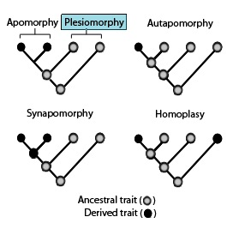(probably non-informative.)

**Def. synapomorphy**: Synapomorphy is a shared derived character or trait state that distinguishes a clade from other organisms. It is informative.

**Kor.**: Synapomorphies are homologous traits.

**Def. autapomorphy**: A distinctive feature, known as a derived trait, that is unique to a given taxon. That is, it is found only in one taxon, but not found in any others or outgroup taxa. It is non-informative.

Reptilia is a paraphyletic group, because birds are too different from common reptiles such as crocodile or turtles.

**Pitfalls**: phenotypes are obviously influenced by the environment and the genotype; only the genotype is heritable; there are phenotypic similarities due to convergence (analogous/homoplasy – wings of birds and wings of bats are structurally different, but have same function).

**Def. parsimony**: A phylogenetic tree that has the least characteristic trait changes (minimizes homoplasy). This is a criterion for identifying the most probable (= best) phylogenetic tree.

Mutations can create synapomorphies and reversals can remove them.

11.10.2017

**Def. cooption** (also known as exaptation): A process by which a structure or system with an original function adds or changes to a new function.

25.10.2017

**Population Genetics I**

Heritability: variance(genotype) / variance(phenotype) = h**2 = sigma_G**2/sigma_P**2

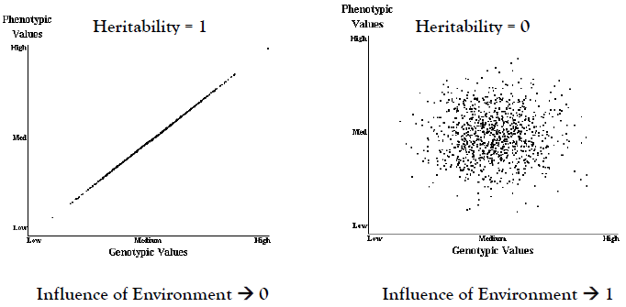Alternative way of calculating the heritability:

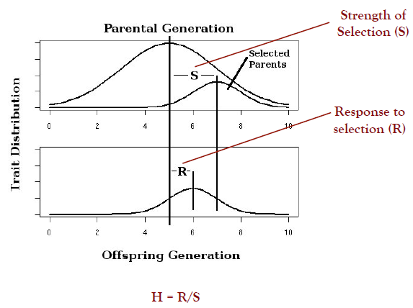

**Forces that cause evolution in a real world setting**: mutation, gene drift, sexual selection, mate choice selection among the gametes, migration.

**Criteria for a Hardy-Weinberg principle (=: HWP)**: infinite population size, random mating choice, no selection, no migration, no gene drift, no mutations (those 4 are known as no evolution).

The HWP can be seen as the null hypothesis which we use to test if a population is evolving.

Hardy-Weinberg Equlibrium: 1 = p**2 + 2pq + q**2

If the population is not evolving, then it is in the HWE with following consequences: populations follow the laws of Mendelian genetics, allele frequencies are always stable over time and do not change, they are already stable after the first round (initial frequencies = final frequencies [a_0 = a_n for all n]) and they can be stable at any value between 0 and 1.

Violations of the HWP: allele frequencies change over time or genotype frequencies do not meet expected values for p**2, q**2, 2pq.

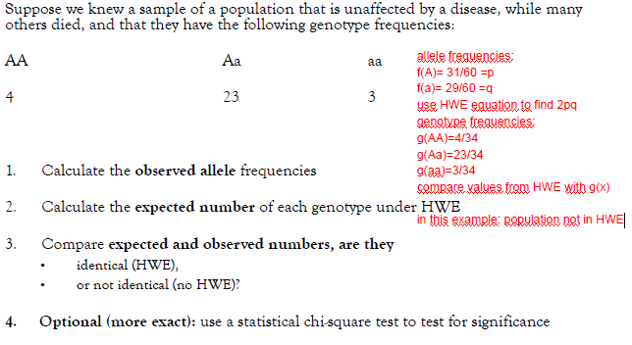

Directional selection favors individuals at one end of the phenotypic range.

Disruptive selection favors individuals at both extremes of the phenotypic range.

Stabilizing selection favors intermediate variants and acts against extreme phenotypes.

Frequency-dependent selection: a) negative FDS, favors the rarest variant and acts against the more common ones; b) positive FDS, the most common variant is favored over the rare ones.

**Selection coefficient s**

**Def.**: w = 1 – s ⬄ s = 1 – w

The larger s the faster allele frequencies change over time.

**Calculating changes in genotype and allele frequencies changes**:

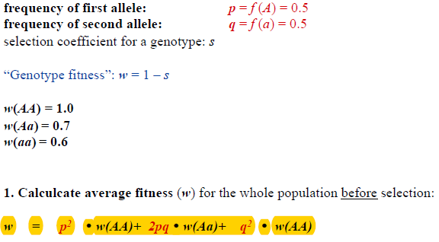

Genotype frequencies after selection:

f’(AA) = p**2 * w(AA)/w  
f’(Aa) = 2pq + w(Aa)/w  
f’(aa) = q**2 * w(aa)/w

Allele frequencies of gametes after selection and random mating:

  
  


1.11.2017

**Def. selective effect**: s > 1/N, 1/N is also known as the drift barrier. s is an empirical value: Transfect a mutation into an organism and let the population grow for some time. In the end, calculate the relative abundance of mutants in the population (=: s). If s > 1/N, then the mutation is positively selective and will manifest itself in the population. Else, selection does not recognize the mutation due to randomness in the background.

**Induced mutagenesis: SOS response**

Reaction to interrupted DNA replication can lead in some bacteria to an increased rate of mutations through error-prone polymerase (more mutations), increased DNA uptake (recombination), activation of sleeping prophages.

**Selection balance for deleterious recessive alleles**

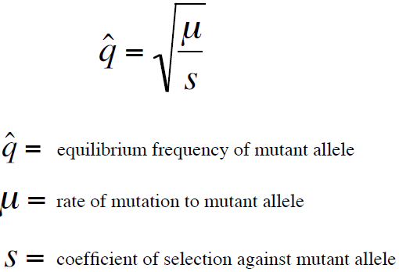

In dominant alleles, it is simply: q_hat = mu

8.11.2017

**Genetic Drift**

Fixation of an allele:

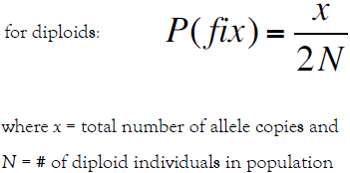

**Kor.**: Selfing reduces heterozygosity frequency.

**Genetic linkage**

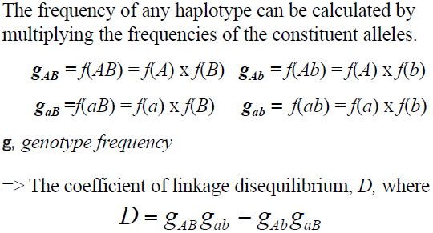

Under Hardy-Weinberg and linkage equilibrium haplotype frequencies **do not change over generations**.

Deviations from HW expectations suggests that one of three mechanisms causing linkage disequilibrium is at work: Selection on multi-locus genotypes; Genetic drift; Population admixture (i.e. migration)

06.12.2017

**Social variation**

Individuals in a community vary in the following aspects: time spent near each other, frequency of interaction with other individuals, kind of interaction and group size.

**Benefits of living in a group**

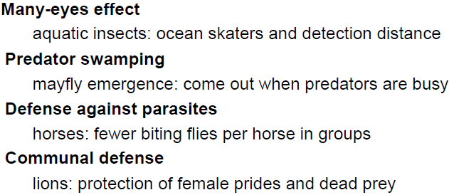

**Microbial social behaviour**

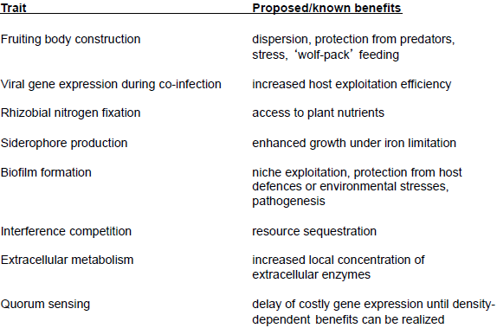

**Negative aspects**: disease transmission, competition over sexual mates and resources.

How can altruism be maintained in a population and selfishness restricted?

**Def. Kin selection**: Selection can favour traits that result in decreased fitness of an actor if they increase the fitness of close relatives.

**Kor.**: Selection for alleles shared by close relatives that might cause individuals to behave in a manner that is detrimental to their own individual fitness but beneficial for the spread of the alleles under selection.

**Hamilton’s rule**

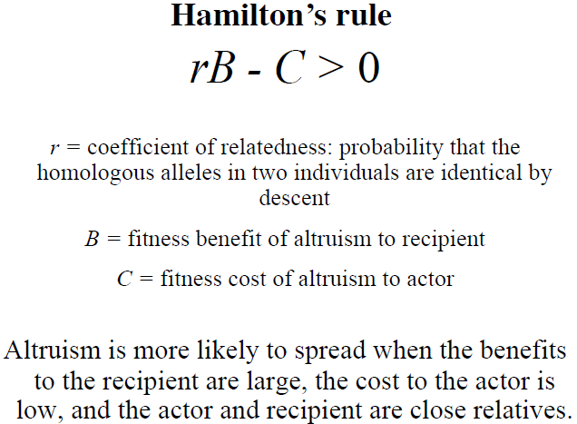

**Indirect fitness benefit**: A fitness benefit mediated through increasing the fitness of relatives rather than directly accrued to oneself is an example of an indirect fitness benefit.

**Why do organisms die? Three hypotheses**

